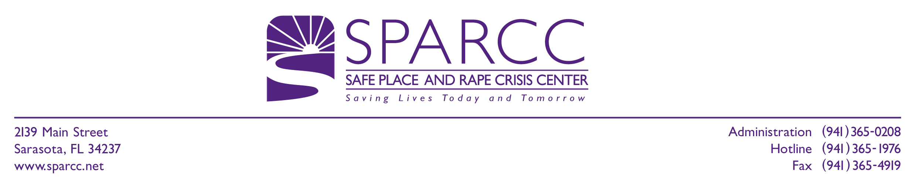
VOLUNTEER APPLICATION

Name _________________________________________________________________Date____________
Last First Middle Initial

Address _______________________________________________________________________________
Street City State Zip Code

Phone Numbers: (H)____________________(W)____________________(Fax)______________________

Cellular_______________________________Email___________________________________________

Age__________ D/O/B ____________ Marital Status _______ Children____________ Ages___________

Education Completed_________________Major______________Skills____________________________

Present Occupation ___________________Work Experience_____________________________________

Time Available: (days)_________________(hours)_______________Are you available weekends?______

Do you drive?__________How did you learn about SPARCC?____________________________________

Office Experience _______________________________________________________________________

______________________________________________________________________________________

Why do you want to be a volunteer? ________________________________________________________

______________________________________________________________________________________

What problem solving skills do you have? ___________________________________________________

______________________________________________________________________________________

What do you feel are your personal attributes? ________________________________________________

______________________________________________________________________________________

What do you feel are your liabilities? _______________________________________________________

______________________________________________________________________________________

If you have previously worked/volunteered in a CRISIS, REFERRAL or SOCIAL SERVICE AGENCY, please describe your experience, responsibilities, training: _______________________________________

______________________________________________________________________________________

______________________________________________________________________________________

______________________________________________________________________________________

Over

How do you react in a crisis? ______________________________________________________________

______________________________________________________________________________________

______________________________________________________________________________________

______________________________________________________________________________________

Your feelings about rape?_________________________________________________________________

______________________________________________________________________________________

______________________________________________________________________________________

______________________________________________________________________________________

Your feelings about domestic violence?______________________________________________________

______________________________________________________________________________________

______________________________________________________________________________________

______________________________________________________________________________________

Please describe any previous experience in resolving a domestic violence crisis:
______________________________________________________________________________________

______________________________________________________________________________________

______________________________________________________________________________________

______________________________________________________________________________________

VOLUNTEER OPPORTUNITIES

At this time, the Hospital Advocacy Team is the only advocacy volunteer opportunity available.

Hospital Advocacy Team
(Includes hospitals in Sarasota, Venice, Englewood and Northport)

Please mail your application to 2139 Main Street, Sarasota, FL 34237

